Report for internship task 6

*Name: Shoaib Ahmed*

*Internship iD: TN/IN02/PY/027*

**Task Objective:**

The objective of this task is for the docker desktop

**snippets:**

cd Desktop\flask_app

D:

cd Projects\flask_app

dir in powershell

PS C:\Users\Saad\flask_docker_app> docker run -p 5000:5000 flask-docker-app

* Serving Flask app 'app'

* Debug mode: off

WARNING: This is a development server. Do not use it in a production deployment.

* Running on all addresses (0.0.0.0)

* Running on http://127.0.0.1:5000

* Running on http://localhost:5000

Press CTRL+C to quit

**screenshots:**

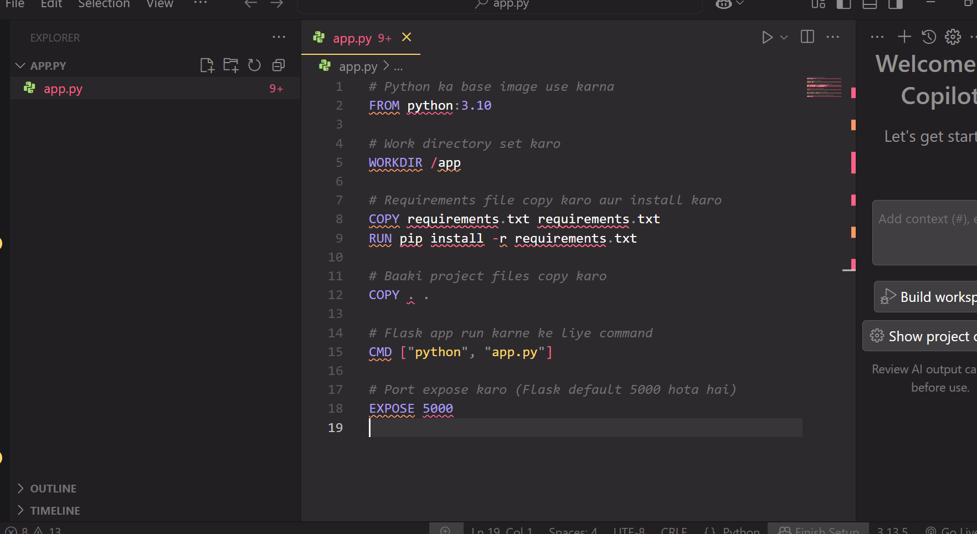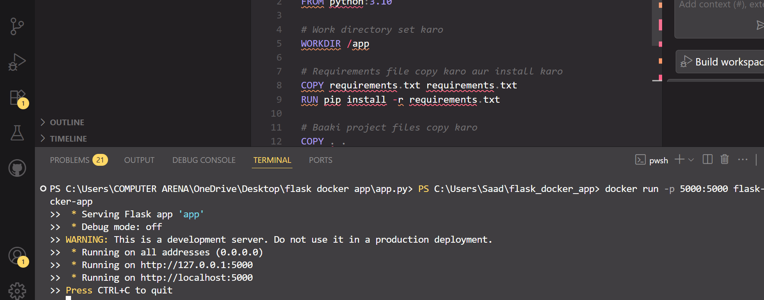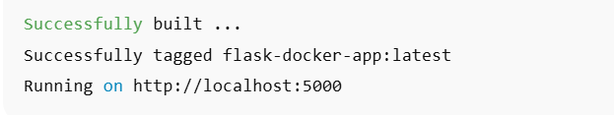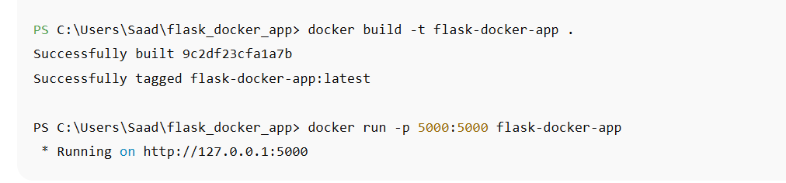

**Reflections:**

I encountered several difficulties, but this helped me gain valuable knowledge. I learned how to use commands in PowerShell and also understood the process of creating an image in the Docker application.